**DAY 4**   **Pramit Kumar Bhaduri**

Q1. Find out the mail servers of the following domains:

1. Ibm.com
2. Wipro.com
3. 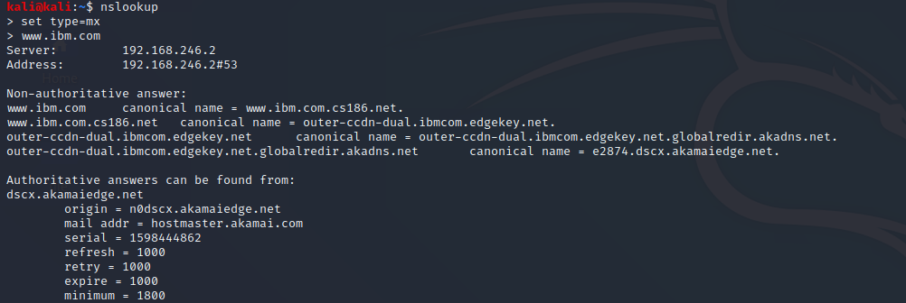
4. 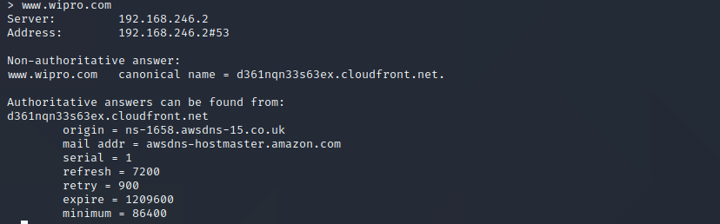

Q2. Find the location where these email servers are hosted.

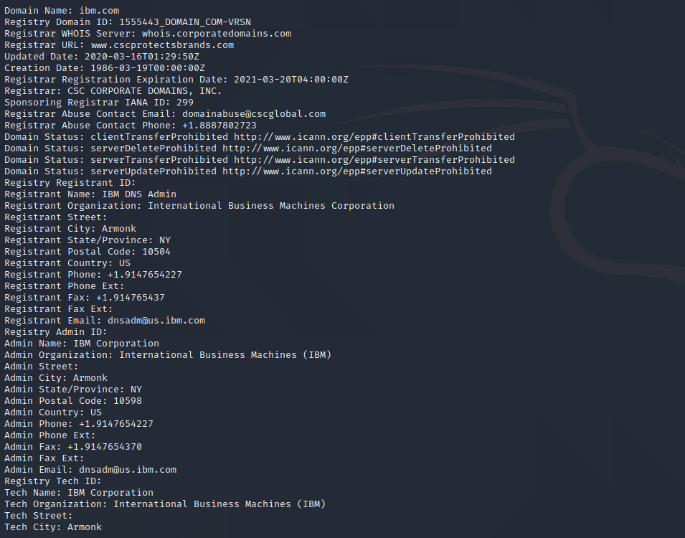

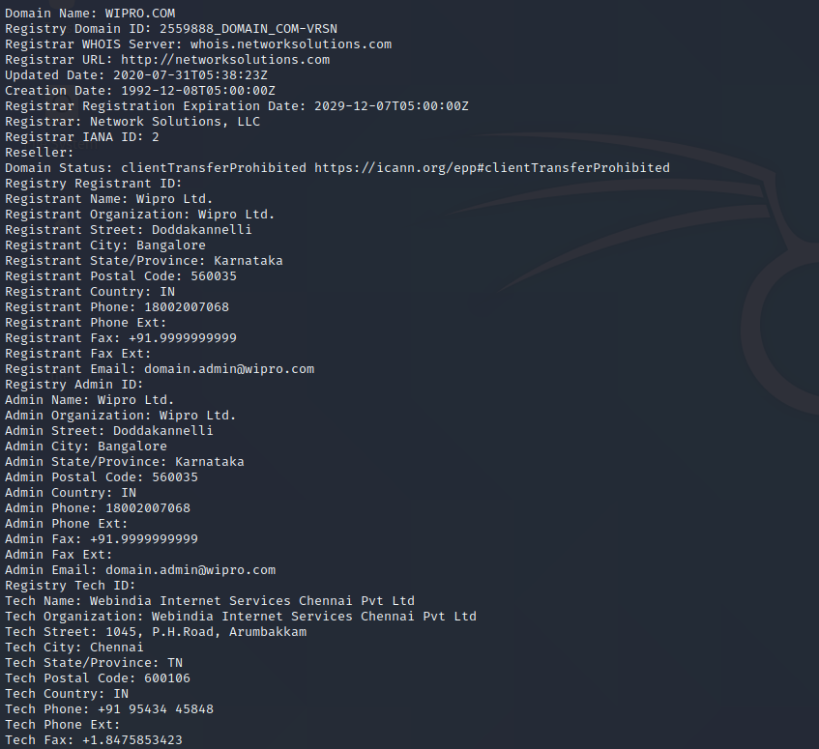

Q3. Scan and find out open ports at 203.163.246.23.

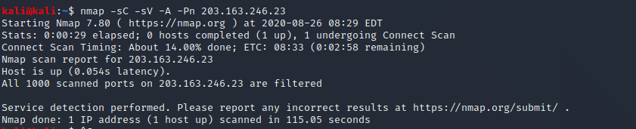

NO PORTS OPEN :(

Q4. Install Nessus in a VM and scan your laptop for CVE.

